| Lab – 1.1 | Section1_Priyanka  Railway_Reservation_Database System |
| --- | --- |
| IT214 Database Management System, Autumn’2022; Instructor: minal_bhise@daiict | |

**Objectives**: I) Create tables using below given schema & DDL Scripts in Appendix A.

II) Load data into tables using csv files given in your classroom.

III) Run simple queries.

**Submission**: Each student needs to Upload a **single .pdf** file which will contain following things for all the queries listed in (III).

1. English query and SQL Query in the given sequence.
2. Screenshot of results.
3. Count of tuples in the results.
4. **Create tables using below given schema:** 
   1. Expand your Database => Open Query Tool window from Tool. or From SQL Shell.

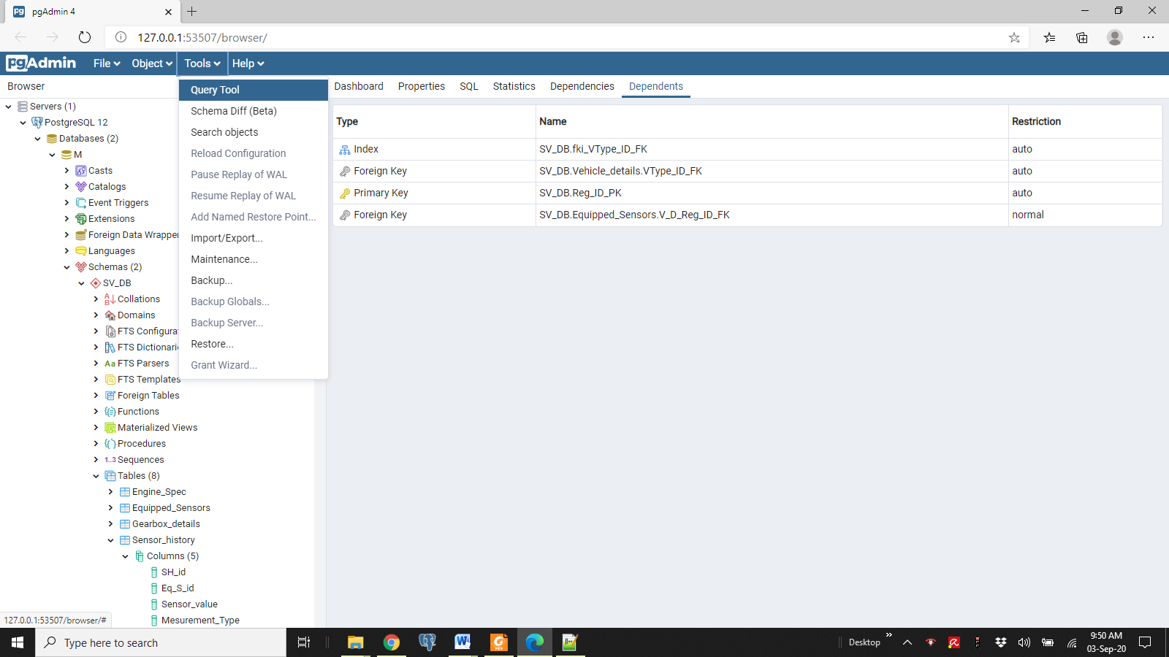

* 1. Type following to create Schema. –

**CREATE SCHEMA rail_db;  
SET SEARCH_PATH TO rail_db;**

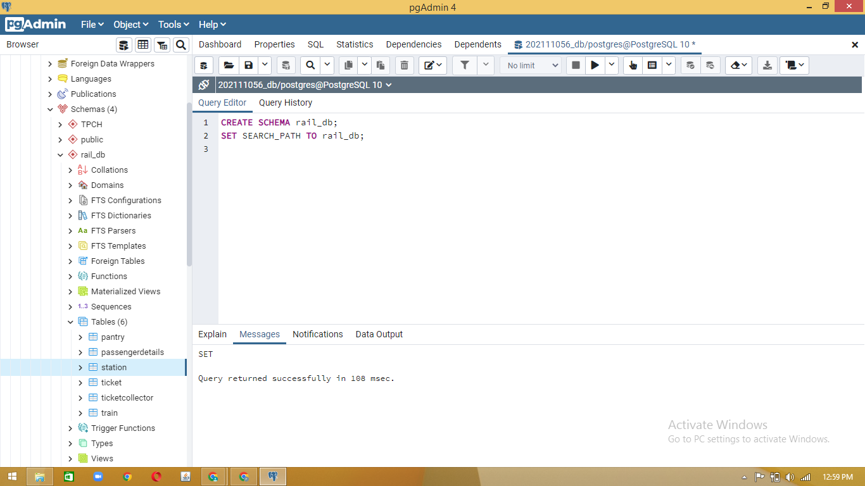

* 1. Table Schema Diagram. Find the DDL Scripts after the queries section III.

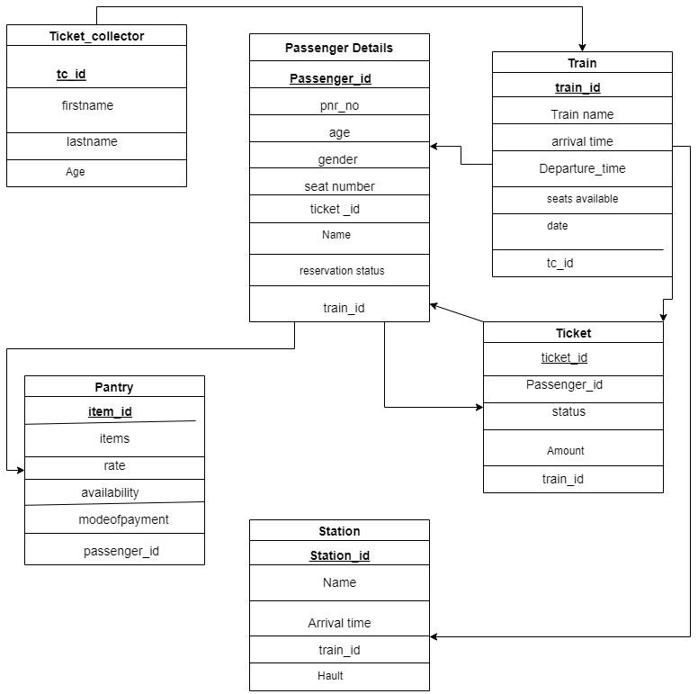

1. **Load data into tables using csv files given on classroom file lab1.zip**

COPY "passengerdetails" FROM 'G:\TAdbms\S8-G3,G6-Priyanka - passenger_details.csv' CSV HEADER;

1. **Run simple queries.**

Query 1: Show all the details of the ticket collector.

Query 2: List the ticket id whose price is greater than Rs3000.

Query 3: Show all the food items that are not available.

Query 4: Count the number of female passengers.

Query 5: Find out the smallest age of passenger travelling.

Query 6: Find out the eldest tc among all the ticket collectors.

Query 7: Write a query to print all the food items being served on the train.

Query 8: Print the name of trains where numb of seats available is greater than 5

Query 9: Print the number of rows present in the passenger table

Query 10: Find the ticket id of the costliest ticket.

Query 11: Show the second highest priced ticket_id

Query 12: Print the name of passengers whose ticket is confirmed

Query 13: Print all the names of stations.

Query 14: Print the name of all the ticket collectors who are below the age of 40.

Query 15: Write a query to print the number of foods that were available & their mode of payment was online.

1. **Appendix A: DDL Scripts to create tables.**

-----------------------------------------------------------------------------------------------------------------

CREATE TABLE IF NOT EXISTS rail_db.pantry

(

item_id integer NOT NULL,

item character(30) COLLATE pg_catalog."default",

rate integer,

availability character(30) COLLATE pg_catalog."default",

payment_mode character(30) COLLATE pg_catalog."default",

passenger_id integer,

CONSTRAINT pantry_pkey PRIMARY KEY (item_id),

CONSTRAINT passenger_id FOREIGN KEY (passenger_id)

REFERENCES rail_db.passengerdetails (passenger_id) MATCH SIMPLE

ON UPDATE NO ACTION

ON DELETE NO ACTION

NOT VALID

)

WITH (

OIDS = FALSE

)

TABLESPACE pg_default;

ALTER TABLE IF EXISTS rail_db.pantry

OWNER to postgres;

CREATE TABLE IF NOT EXISTS rail_db.passengerdetails

(

passenger_id integer NOT NULL,

pnr_no integer,

age integer,

gender character(30) COLLATE pg_catalog."default",

seat_no integer,

ticket_id integer,

name character(50) COLLATE pg_catalog."default",

reservation_status character(40) COLLATE pg_catalog."default",

train_id integer,

CONSTRAINT passengerdetails_pkey PRIMARY KEY (passenger_id),

CONSTRAINT ticket_id FOREIGN KEY (ticket_id)

REFERENCES rail_db.ticket (ticket_id) MATCH SIMPLE

ON UPDATE NO ACTION

ON DELETE NO ACTION

NOT VALID,

CONSTRAINT train_id FOREIGN KEY (train_id)

REFERENCES rail_db.train (train_id) MATCH SIMPLE

ON UPDATE NO ACTION

ON DELETE NO ACTION

NOT VALID

)

WITH (

OIDS = FALSE

)

TABLESPACE pg_default;

ALTER TABLE IF EXISTS rail_db.passengerdetails

OWNER to postgres;

CREATE TABLE IF NOT EXISTS rail_db.station

(

station_id integer NOT NULL,

name character(50) COLLATE pg_catalog."default",

arrival_time time without time zone,

train_id integer,

hault character(30) COLLATE pg_catalog."default",

CONSTRAINT station_pkey PRIMARY KEY (station_id),

CONSTRAINT train_id FOREIGN KEY (train_id)

REFERENCES rail_db.train (train_id) MATCH SIMPLE

ON UPDATE NO ACTION

ON DELETE NO ACTION

)

WITH (

OIDS = FALSE

)

TABLESPACE pg_default;

ALTER TABLE IF EXISTS rail_db.station

OWNER to postgres;

CREATE TABLE IF NOT EXISTS rail_db.ticket

(

ticket_id integer NOT NULL,

passenger_id integer,

status character(30) COLLATE pg_catalog."default",

amount integer,

train_id integer,

CONSTRAINT ticket_pkey PRIMARY KEY (ticket_id),

CONSTRAINT train_id FOREIGN KEY (train_id)

REFERENCES rail_db.train (train_id) MATCH SIMPLE

ON UPDATE NO ACTION

ON DELETE NO ACTION

NOT VALID

)

WITH (

OIDS = FALSE

)

TABLESPACE pg_default;

ALTER TABLE IF EXISTS rail_db.ticket

OWNER to postgres;

CREATE TABLE IF NOT EXISTS rail_db.ticketcollector

(

tc_id integer NOT NULL,

first_name character(30) COLLATE pg_catalog."default",

last_name character(30) COLLATE pg_catalog."default",

age integer,

CONSTRAINT ticketcollector_pkey PRIMARY KEY (tc_id)

)

WITH (

OIDS = FALSE

)

TABLESPACE pg_default;

ALTER TABLE IF EXISTS rail_db.ticketcollector

OWNER to postgres;

CREATE TABLE IF NOT EXISTS rail_db.train

(

train_id integer NOT NULL,

train_name character(50) COLLATE pg_catalog."default",

arrival_time time without time zone,

departure_time time without time zone,

seats_available integer,

date date,

tc_id integer,

CONSTRAINT train_pkey PRIMARY KEY (train_id),

CONSTRAINT tc_id FOREIGN KEY (tc_id)

REFERENCES rail_db.ticketcollector (tc_id) MATCH SIMPLE

ON UPDATE NO ACTION

ON DELETE NO ACTION

)

WITH (

OIDS = FALSE

)

TABLESPACE pg_default;

ALTER TABLE IF EXISTS rail_db.train

OWNER to postgres;